The Effects of Counselling Based on PLISSIT Model on Sexual Dysfunction: A Systematic Review and Meta-analysis

Abstract
Sexual dysfunction is one of the problems that many people face it throughout their life. Counselling with appropriate content for patients can be reduce their sexual problems and improve their quality of life. Therefore, this study was performed to find a comprehensive conclusion about the effect of sexual counselling based on PLISSIT model on sexual dysfunction. To this aim, we searched the Web of Knowledge, PubMed, Cochran, Scopus, google scholar and Persian databases (SID, Magiran, Irandoc and Iranmedex) by the MeSH and non-MeSH terms in title, abstract, or keywords until August 2021. The search strategy was (“Sex Counselling” OR “Counselling, Sex”) AND PLISSIT OR EX-PLISSIT AND (“Sexual Dysfunction” OR “Sexual Disorder” OR “Sex Disorder”) with no limitation in time. All available controlled trials, conducted on individuals with sexual dysfunction, who received counselling based on PLISSIT or EX-PLISSIT Model, were included. The quality of included trials was assessed using the Oxford Center for Evidence Based Medicine checklist. Statistical analyses were done by Comprehensive Meta-analysis Version2. Out of 204 relevant publication trials, 23 trials (2001 female, 19 male) were included in this study. Nine studies had sufficient data for meta-analysis. The meta-analysis showed a significant improve in sexual function (SMD: 1.535; 95% CI: 1.175 to 1.896; P≤0.001) following Counselling Based on PLISSIT Model. Although all studies have shown the positive effect of counselling based on PLISSIT model on sexual function, we recommend conducting more studies in different countries with different sexual cultures in order to clarify the issue as much as possible.

Key-words: PLISSIT model, Sex counselling, Sexual dysfunction, consultation.

Introduction:
Studying, researching and consulting with other people are some of the methods that human usually use of them to solve their problems and concerns. One of the problems that many people face it throughout their life is sexual dysfunction, (1) so they are always trying to find a way to solve it. In this way, studying manuscript with unreliable sources and consulting with non-experts or opportunistic people, not only can't solve the problems, but also can make the situation worse, so training experienced experts and providing counselling with appropriate content for patients can be reduce their sexual problems and improve their quality of life (2). Researches show that sexual satisfaction directly related to self-confidence and quality of life (3). So far, several standard methods proposed to improve sexual dysfunction, one of them is counselling based on PLISSIT model, which described by Annon in 1974 for first time and consists of four main parts (4).
- Permission (P): The consultants and participants introduce themselves and get to know each other at this stage. After explaining the steps and goals of the counselling session, the counselor explains about the anatomy and physiology of the male and female reproductive system, and then the patients can talk about their sexual concerns.
- Limited Information (LI): At this stage, the sexual response cycle and the physical and psychological differences between male and female in each stage of the sexual response cycle are explained. At the end of this session, the counselor answers patient's probable questions and then plans for the next session.
- Specific Suggestions (SS): The counselor explains the effect of various factors such as diseases on sexual function, and according to the history of each patient, offer specific suggestions to solve the sexual problems of the patient.
- Intensive Therapy (IT): The counselor checks the Satisfaction of the subject and summarizes the entire consultation process and in case of need, the patient is referred to the sexologist of the sexuality service (5).
By using the first three phases of PLISSIT model, 80-90% of the patient's sexual problems are solvable (6). EX-PLISSIT is an extended type of PLISSIT model which Permission-giving is one of the most important feature in all phases of consulting (7). Many studies investigated the effect of counselling based on the PLISSIT model on sexual dysfunction caused by several diseases such as multiple sclerosis, diabetes mellitus, breast cancer, HIV and natural events such as pregnancy, childbirth, lactation, menopause and hormonal changes (8). In this study, we tried to review all the mentioned studies and find a comprehensive conclusion about the effect of sexual counselling based on PLISSIT model on sexual function. We hope that health care providers will be able to improve patients' sexual function and provide appropriate services by using the results of this review and meta-analysis study.
MATERIALS AND METHODS
Data sources and search strategy
In this systematic review and meta-analysis study, a systematic search was done to find studies investigating the effect of sexual counselling based on PLISSIT model on sexual function. To this aim, we searched the Web of Knowledge (ISI), PubMed, Cochran, Scopus, google scholar and Persian databases (including SID, Magiran, Irandoc and Iranmedex) by the MeSH and non-MeSH terms in title, abstract, or keywords until August 2021. The search strategy was (“Sex Counselling” OR “Counselling, Sex” OR “Counselling’s, Sex”) AND PLISSIT OR EX-PLISSIT AND (“Sexual Dysfunction” OR “Sexual Disorder” OR “Sex Disorder”) and Persian equivalent keywords with no limitation in time. In addition, reference section of relevant trials, systematic reviews and meta-analysis were manually checked to identify further trials missed by electronic search. Publication bias was assessed by funnel plots and Egger's test.
Inclusion criteria
Trials were included in the systematic review and meta-analysis if they met the following criteria:
)1( Conducted on a sample of women or men with Sexual Dysfunction.
)2( Designed as a clinical trial.
)3( Compared the sexual counselling based on PLISSIT OR EX-PLISSIT model in the intervention group with of the control group.

Study selection and data extraction
Initially, all studies with related keywords were collected. In the next step, the title and abstract of each article were reviewed and irrelevant studies and articles with non-English language (except Persian language) were removed. The full-texts of the retrieved articles were reviewed by two independent authors (ZN and MI). A third author (M.GH) was also considered as the arbiter to resolve any disagreements. The studies that went through these steps were arranged according to a predetermined checklist. The checklist included items such as first author, year of publication, country, study design, participant, intervention, comparison, tool, dropout, blinding method and outcome. The disagreement between the researchers was resolved through discussion with a third researcher.

Outcome measures

Primary outcome measures included:
sexual dysfunction item: I) Desire, II) Arousal, III) Orgasms, IV) Pain, V) Satisfaction, and VI) Total Score

Quality assessment of the included studies
Oxford Centre for Evidence Based Medicine checklist for RCTs used for assessing the quality of the chosen studies (9). This instrument is designed in two part that determine two segments; Internal Validity: containing of six general queries regarding the way of patient assignment, matching and similarity of groups, equality of allocated treatment, intention-to-treat analysis and Losses to follow-up, effect size and blindness which was answered with three options Yes, No and Unclear.

List of criteria for assessing the quality of studies, included:
"A: Was the assignment of patients to treatments randomized?
B: Were the groups similar at the start of the trial?
C: Aside from the allocated treatment, were groups treated equally?
D: Were all patients who entered the trial accounted for? – And were they analysed in the groups to which they were randomized? (1: Losses to follow-up and 2: (intention-to-treat)
E: Were measures objective or were the patients and clinicians kept "blind" to which treatment was being received?
F: What were the results (9) "?

Statistical analyses
We estimated the difference between means in two ways: difference in means (MD) and standardized difference in means (SMD). The latter was used when studies included in the meta-analysis measured the same outcome by different measurement units. Changes in mean (sexual dysfunction item: I) Desire, II) Arousal, III) Orgasms, IV) Pain, V) Satisfaction, and VI) Total Score) at baseline and endpoint were assessed. The main effect size used in this meta-analysis was standardized difference in means of changes in variables in the counselling and control groups. We used the Cochrane recommendations for effect size calculations. We interpreted the results using random effects model (Der-simonian and Laird method). For heterogeneity evaluation, Cochrane Q test (p<0.05 as statistically significant) and I-squared index were used. The latter was used to assess how much of the variance across studies was likely to be real and was not due to sampling errors. Moreover, a sensitivity analysis was performed by removing studies one by one and checking the p-value of the pooled effect (leave-one-out sensitivity analysis). The Begg's funnel plots and the asymmetry tests (Egger's and Begg's test) were employed to investigate the publication bias. All statistical analyses were done by Comprehensive Meta-analysis Version 2 (Biostat, Englewood, NJ, USA).
Result
Study description
Out of 204 relevant publication trials, 23 trials were included in this review and meta-analysis study according to the inclusion criteria. The selection process of trials included in our study is described in Figure 1. The summarized characteristics of the included studies are shown in Table 1.
Figure 1. PRISMA Flow chart for systematic review and meta-analysis
Table 1. Characteristics of randomized controlled trials included in the systematic review

All these studies were conducted between 2009 and 2020 in three countries: Iran, Turkey and Egypt. Overall, 2001 female participated in all chosen trials and only one trial used couples to study which involved 19 males (25). The age of the participants was various from 18 to 55 years. The intervention included the counselling session based on PLISSIT or EX-PLISSIT model. The duration of intervention was different from four weeks to nine months, the number of these session were varied from one to eight and duration of each session varied from 15-20 minutes to 120 minutes. All studies had a control group which due to the specific nature of each study, the control group received routine care but in one study the control group received counselling based on SHM (Sexual Health Model) method in compare with counselling based on PLISSIT model in intervention group (1). These trials were performed on female with different medical situation, such as multiple sclerosis (4,5,10,19), breast cancer (11), diabetes (14,18), HIV(2), spinal cord injury (12), Polycystic Ovarian Syndrome (PCOS) (16), Stoma (25), pregnancy (6,8,15,22), postpartum (7,13,20), Lactating women (23), nulliparous and breastfeeding women (21) and married women (1,17,24). Most studies used Female Sexual Function Index (FSFI) to measure sexual function before and after the intervention (2,4,7,8,12,13,14,16,18,22,23,24). Other tools like "Sexual Quality Of Life-Female (SQOL-F), Brief Sexual Symptom Checklist for Women (BSSC-W), Married Women’s Sexual Satisfaction Questionnaire (MWSSQ), Golombok–Rust Inventory of Sexual Satisfaction (GRISS), Sexual Dysfunctional Beliefs Questionnaire, Hudson's Index of Sexual Satisfaction, Brief Index of Sexual Function for Women and Female Sexual Distress Scale, sexual intimacy and sexual satisfaction scores, Arizona Sexual Experience Scale, Linda Berg questionnaires and questionnaire of sexual quality of life" were used to evaluation of sexual function. Due to the nature of the studies, blinding was not possible and some studies have pointed this impassibility.
Among 23 trials, 9 studies (2,7,8,12,16,18,22,23,24) reported their results quantitatively and reported the FSFI index completely. Therefore, just nine trails had sufficient data for meta-analysis and other experiments not suitable for meta-analysis and only reviewed. The result of this study shows that, all quantitative and qualitative studies had the positive effects of counselling based on PLISSIT model on sexual function.

Assessment of quality of studies
The methodological quality of these studies was shown in Table 2.
Table2. Methodological assessment of study quality
Randomization was performed in all trials except two of them (15, 25). Participants groups were similar at the beginning of the experiment in terms of demographic characteristics and only in one study there was significant difference between them at the beginning of trials (25). Due to the nature of the studies, treating the intervention and control groups were not the same and blinding was not possible. Some studies considered the impossibility of blinding therefore received positive points for this part in the methodological quality table (1, 7, 4, 5, 8, 11, 13, 20). Dropout rates range from 0% to 46% and only in two studies, dropout was not considered (2, 24). In the end, all studies agreed on the positive effect of counselling based on PLISSIT model on sexual function.
Meta-analysis results
Figure 2 shows the forest plots of the meta-analysis of sexual counselling based on PLISSIT model. As shown in the figure, the effect of sexual counselling based on PLISSIT model on total score of sexual function after the intervention was statistically improved compared to the control group and before intervention (1. 535; (95% CI: 1.175 to 1.896), p < 0.001; heterogeneity I² = 97 %: p< 0.001).
Figure 2. Effects of counselling on total score. The horizontal lines denote the 95% CI, ■ point estimate (size of the square corresponds to its weight); ♦, combined overall effect of treatment

Other sub score of FSFI like orgasm score (1. 122; (95% CI: 0.862 to 1.381), p < 0.001; heterogeneity I2 = 59 %: p= 0.012), desire (1. 272; (95% CI: 0.942 to 1.602), p < 0.001; heterogeneity I2 = 74 %: p< 0.001), satisfaction (1. 142; (95% CI: 0.653 to 1.631), p < 0.001; heterogeneity I2 = 88%: p< 0.001), arousal (1. 273; (95% CI: 0.773 to 1.784), p < 0.001; heterogeneity I2 = 88%: p< 0.001), pain (0. 982; (95% CI: 0.769 to 1.194), p < 0.001; heterogeneity I2 = 41%: p= 0.091), and lubricant (1. 258; (95% CI: 0.653 to 1.864), p < 0.001; heterogeneity I2 = 91%: p< 0.001) was statistically improved compared to the control group after intervention (Figure 3).
Figure 3. Effects of counselling on sub score of FSFI. (Standardized difference in means and 95% CI)

Publication Bias:
The funnel plot of Counselling Based on PLISSIT Model on Sexual Dysfunction shown in figure 4.
Figure 4. Funnel plot of Counselling Based on PLISSIT Model on Sexual Dysfunction
The funnel plot in Fig 4 demonstrates no significant bias in publications based on the Egger’s linear regression (intercept = 4.09; S.E. =7.73.; 95% CI: 14.20 to 22.39; t=0.51; df=7.00; two-tailed P = =0.61) and Begg’s rank correlation (Kendall’s Tau with continuity correction = 0.13; z = 0.52; two-tailed P-value = 0.60). Duval and Tweedie ‘trim-and-fill’ correction resulted in the imputation of one potentially missing study and an adjusted effect size of 1.52 (95% CI: 1.74 to 1.89). The ‘fail-safe N’ test indicated that 676.00 studies would be required to turn the effect size into a non-significant value. Figure 5 show sensitivity analysis that was used to test the heterogeneity sources and robustness of study conclusions by removing data that participate in the summary effect size of the meta-analysis one by one, then observing whether the conclusions changed.

Figure 5. The results of the leave-one-out sensitivity analysis

Discussion
This review and meta-analysis study is a comprehensive study on the effect of counselling based on PLISSIT model on sexual function. We were able to achieve a clear and transparent result by collecting the results of all relevant studies. All trials agreed with the positive effect of this method on sexual function. Therefore, due to the high efficiency compared to the short implementation time of this program, health care providers can use this method to improve the sexual function of their patients.
SHM (Sexual Health Model), IMB (Information-Motivation-Behavioural), TTM (Trans Theoretical Model), EMS (Enhancing Marital Sexuality) are among the other counselling and training methods that are useful for reducing 80-90% sexual problems (11). Farnaz Farnam et al (2014) compared counselling based on PLISSIT and SHM models on sexual function of married women that the result of their study showed both counselling methods had a significant effect on sexual performance, but SHM seems to be more cost-effective in terms of time and money.¹ Nho JH (2013) investigated the effect of PLISSIT method on sexual function of women with gynaecological cancer and after holding four 90-minute sessions concluded that this method improves sexual function, increases cordiality between couples, reduces female sexual distress in the intervention group compared to the control group (12). Tutuncu and Yildiz (2012) examined the effect of this counselling method on women's sexual function after hysterectomy and they also reported the effectiveness of the PLISSIT method after intervention (13). The above two trials were not included in our study due to the publication language (Korean) according to the inclusion criteria, but were completely related to the consultation based on the PLISSIT model. Almeida et al (2019) examined the effect of PLISSIT model on women with breast cancer in five sessions of 120 minutes once a week (28) and Abdelhakm et al (2018) investigated this effect on postpartum women in 6 sessions of one hour for three weeks (29). Both trials showed positive effect of this method on sexual function but these trials remove of our study because they didn’t have control group. It seems that PLISSIT method has a positive effect by creating a suitable situation for talking about sexual problems, eliminating sexual worries and answering patient’s questions appropriately (14).
Most of the trials in this review and meta-analysis study were performed in Iran. Considering that the culture and attitudes of different societies have strong effects on sexual function, it is recommended to perform future trials of this counselling method in other countries with different sexual cultures. In addition, only one study has evaluated the effect of this counselling method on men, so it is recommended further studies performed on men and couples. The limitation of our review and meta-analysis study pertain to the low number of quantitative studies, but the great effort of the authors to achieve a comprehensive and clear result away from bias is one of the positive points of this study.
Since the family is the most important pillar of society, each action to increase their health and reduce their worries can increase the health of society. Therefore, health professionals can take effective steps to promote community health based on the results of this study and similar experiments.
CONCLUSIONS
Although all studies have shown the positive effect of counselling based on PLISSIT model on sexual function, we recommend conducting more studies in different countries with different sexual cultures in order to clarify the issue as much as possible.
Acknowledgement
The authors thank the Torbat Heydariyeh University of Medical Sciences who funded this study.

References:

1. Farnam F, Janghorbani M, Raisi F, Merghati-Khoei E. Compare the effectiveness of PLISSIT and sexual health models on Women's sexual problems in Tehran, Iran: a randomized controlled trial. The journal of sexual medicine. 2014; 11(11):2679-89.
2. Asadi L, Ziaei T, Koochak HE, Montazeri A, Rezaei E, Behboodi-Moghadam Z, et al. Effect of counselling based on PLISSIT model on sexual function of HIV-positive married women. HIV & AIDS Review International Journal of HIV-Related Problems. 2018;17(3):169-75.
3. Farbod E, Ghamari M, Majd MA. Investigating the effect of communication skills training for married women on couples’ intimacy and quality of life. SAGE Open 2014;4(2):1-4.
4. Khakbazan Z, Daneshfar F, Behboodi-Moghadam Z, Nabavi S.M, Ghasemzadeh S, Mehran, A. The effectiveness of the Permission, Limited Information, Specific suggestions, Intensive Therapy (PLISSIT) model based sexual counselling on the sexual function of women with Multiple Sclerosis who are sexually active. Multiple sclerosis and related disorders 2016; 8:113-9.
5. Kazemi Z, Mousavi MS, Etemadifar M. The effect of counselling based on the PLISSIT model on sexual quality of life of married women with multiple sclerosis referring to MS center in 2019: a randomized, controlled trial. Archives of Women's Mental Health. 2021; 24(3):437-444.
6. Nejati B, Masoumi S, Parsa P, Karami M, Mortazavi A. Effect of counselling based on the PLISSIT model on pregnant women’s sexual satisfaction: a randomised controlled trial. Family Medicine & Primary Care Review 2020; 22(1):43-48.
7. Malakouti J, Golizadeh R, Mirghafourvand M, Farshbaf-Khalili A. The effect of counselling based on ex-PLISSIT model on sexual function and marital satisfaction of postpartum women: A randomized controlled clinical trial. Journal of Education and Health Promotion. 2020;9:284.
8. Shahbazi Z, Farshbaf-Khalili A, Sattarzadeh N, Kamalifard M. The effect of sexual counselling based on PLISSIT model on sexual function of pregnant women: a randomized controlled clinical trial. International Journal of Women's Health and Reproduction Sciences 2019;7(3):372-9.
9. Howick J CI, Glasziou P, Greenhalgh T. The 2011 Oxford Cebm Levels Of Evidence (Introductory Document. (Oxford CEBM 2011;Retrieved January(20,2011.).
10. Azari-Barzandig R, Sattarzadeh-Jahdi N, Nourizadeh R, Malakouti J, Mousavi S, Dokhtvasi G. The Effect of Counselling Based on EX-PLISSIT Model on Sexual Dysfunction and Quality of Sexual Life of Married Women with Multiple Sclerosis: A Randomized Controlled Clinical Trial. Sexuality and Disability 2020; 38(2):271-284.
11. Khoei EM, Kharaghani R, Shakibazadeh E, Faghihzadeh s, Aghajani N, E.Korte j. Sexual health outcomes of PLISSIT-based counselling versus grouped sexuality education among Iranian women with breast cancer: A randomized clinical trial. Sexual and Relationship Therapy 2020; 1-12.
12. Rezaei-Fard M, Lotfi R, Rahimzadeh M, Merghati-Khoei E. Effectiveness of Sexual Counselling Using PLISSIT Model to Promote Sexual Function of Women with Spinal Cord Injury: A Randomized Controlled Trial. Sexuality and Disability 2019; 37(4):511-9.
13. Karimi F, Babazadeh R, Asgharipur N, Esmaily H, Latifnejad- Roudsari R. The Effectiveness of Counselling using PLISSIT Model on Depression, Anxiety and Stress, among Postpartum Women with Sexual Dysfunction: A Randomized Trial. Journal of Midwifery and Reproductive Health 2019; 7(4):1912-20.
14. Mehrabi M, Lotfi R, Rahimzadeh M, Merghati-Khoei E. Effectiveness of sexual counselling using PLISSIT model on sexual function of women with type 2 diabetes mellitus: results from a randomized controlled trial. International Journal of Diabetes in Developing Countries 2019; 39(4):626-32.
15. Heidari M, Shokravi FA, Kiani Aciabar A. The effect of an educational intervention based on the PLISSIT model on sexual satisfaction of pregnant women in the third trimester of pregnancy. Payesh (Health Monitor) 2019; 18(5):505-515. (In Persian)
16. Golbabaei F, Jamshidimanesh M, Ranjbar H, Azin SA, Moradi S. Efficacy of sexual counselling based on PLISSIT model on sexual functioning in women with polycystic ovarian syndrome. Journal of Mazandaran University of Medical Sciences 2019; 29(172):43-52. (In Persian)
17. Mohammadzadeh Moghaddam M, Moradi M, Mirzaii Najmabadi K, Ramezani MA, Shakeri MT. Effect of counselling on the sexual satisfaction level of women with sexual dysfunction using PLISSIT model focused on dysfunctional sexual beliefs. Evidence Based Care 2019; 9(3):49-57.
18. Khedr NFH, Metwally NS. Effect of PLISSIT Model Sexual Counselling on Sexual Function among Women with Diabetes. Journal of Nursing and Health Science 2018; 7(4):34-42.
19. Daneshfar F, Behboodi-Moghadam Z, Khakbazan Z, Nabavi SM, Dehghan Nayeri N, Ghasemzadeh S. The Influence of Ex-PLISSIT (Extended Permission, Limited Information, Specific Suggestions, Intensive Therapy) Model on Intimacy and Sexuality of Married Women with Multiple Sclerosis. Sexuality and Disability 2017; 35(4): 399-414.
20. Yörük F, Karaçam Z. The effectiveness of the PLISSIT model in solving postpartum sexual problems experienced by women. Athens Journal of Health 2016; 3(3):235-254.
21. Banaei M, Tork Zahrani S, Pormehr-Yabandeh A, Ozgoli G, Azad M. Investigating the impact of counselling based on PLISSIT model on sexual intimacy and satisfaction of breastfeeding women. International Journal of Pharmaceutical Research and Allied Sciences 2016; 5(3):489-499.
22. Rostamkhani F, Moghadam R, Merghati Khoei E, Jafari F, Ozgoli G. The effect of counselling using the PLISSIT model on sexual function of pregnant women. Preventive Care in Nursing & Midwifery Journal 2016; 6(1):18-28. (In Persian)
23. Torkzahrani S, Banaei M, Ozgoli G, Azad M, Mahmoudikohani F. The effectiveness of consultation based on plissit model on sexual function of lactating women. Journal of Urmia Nursing and Midwifery Faculty 2016; 14(7):639-47. (In Persian)
24. Rostamkhani F, Ozgoli G, Merghati KE, Jafari F, Alavi MH. Effectiveness of the PLISSIT-based Counselling on sexual function of women. Advances in Nursing & Midwifery 2012; 22(76):1-9. (In Persian)
25. Ayaz S, Kubilay G. Effectiveness of the PLISSIT model for solving the sexual problems of patients with stoma. Journal of clinical nursing 2009; 18(1):89-98.
26. Nho JH. Effect of PLISSIT Model Sexual Health Enhancement Program for Women with Gynecologic Cancer and Their Husbands. Journal of Korean Academy of Nursing 2013; 43(5):681-9.
27. Tutuncu B, Yildiz H. The influence on women's sexual functions of education given according to the PLISSIT model after hysterectomy. Procedia-Social and Behavioral Sciences 2012; 47:2000-2004.
28. Almeida NGd, Britto DF, Figueiredo JV, Magalhaes Moreira TM, Carvalh REFL,Melo Fialho AV. PLISSIT model: sexual counselling for breast cancer survivors. Revista brasileira de enfermagem 2019; 72(4):1109-1113.
29. Abdelhakm EM, Said AR, Elsayed DMS. Effect of PLISSIT model sexual counselling program on sexual quality of life for postpartum women. American Journal of Nursing Science 2018; 7(2):63-72.

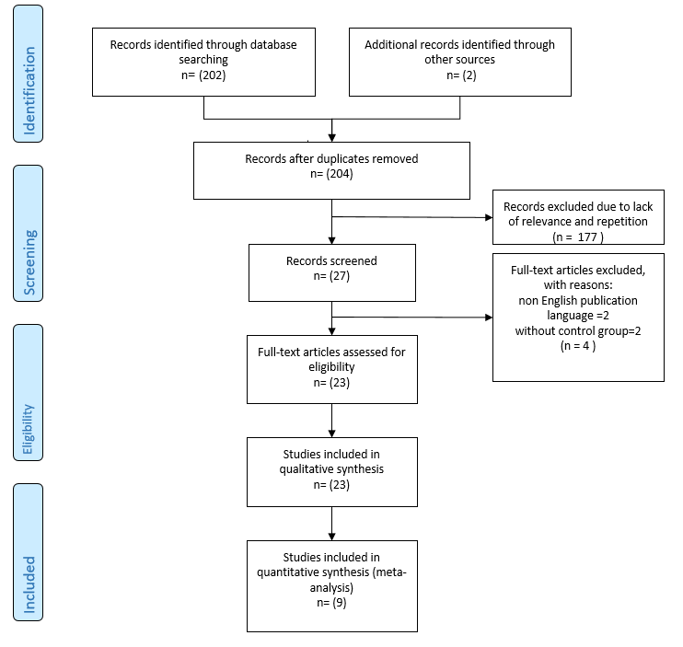

Figure 1. PRISMA Flow chart for systematic review and meta-analysis

Table 1. Characteristics of randomized controlled trials included in the systematic review
Outcome(s) | blinding method | tools | Dropouts (%) | Baseline  comparability | participants  control | participants  Intervention | Type of control | Intervention | Age (/Y) | Duration | Design | Author year Country
counselling base on EX-PLISSIT model had a positive effect on reducing sexual dysfunction but did not change the quality of life in patients with MS. | Not reported | MSISQ-19, SQOL-F, EDSS, FSS,  BDI | 0% | N=70 | N=35  married women with MS | N=35  married women with MS | The control group received the usual care of the disease | counselling based on the Ex-PLISSIT model in a session of  60–90 min | 18-45 | 2 month | RCT | Roya Azari-Barzandig et al (10)  2020  Iran
We found, the Grouped Sexuality Education (GSE) had better results compared to individual counselling based on the PLISSIT model. | impossibility of blinding due to  the nature of the study | sexual behaviour questionnaire | 20% | N=40 | N=25  women with Breast  Cancer | N=25  women with Breast  Cancer | The control group received the centre’s routine care. | Counselling based on PLISSIT model in a session of 45-90 minute | 20-50 | 12 weeks | RCT | Effat Merghati Khoei et al (11)  2020  Iran
The results of the study showed a significant increase in marital satisfaction and improved sexual function after sexual counselling based on the Ex‑PLISSIT model. | impossibility of blinding due to  the nature of the study | FSFI, ENRICH Marital Satisfaction Scale | 0% | N=68 | N=34  postpartum  women (within 3–6 months after childbirth) | N=34  postpartum  women (within 3–6 months after childbirth) | the control group received the routine postpartum care | counselling based on the Ex-PLISSIT model in a session of  60–90 min | 26-27 | 8  weeks | RCT | Jamileh Malakouti et al (7)  2020  Iran
We found that 2 weeks and 2 months after sexual counselling based on PLISSIT model, there was a significant improvement in sexual quality of life in the intervention group compared to the control group. | impossibility of blinding due to  the nature of the study | questionnaire of sexual quality of life | 1.6% | N=61 | N=31 married women who were diagnosed with MS | N=31  married women who were diagnosed with MS | The control group received no intervention | counselling based on the Ex-PLISSIT model in 4 sessions and each session lasted between 45 and 75 min | 15-49 | 2 month | RCT | Zahra Kazemi et al (5)  2020  Iran
Sexual counselling based on EX-PLISSIT model in pregnant women can improve sexual satisfaction. | Not reported | Linda Berg questionnaires | 11% | N=80 | N=45pregnant women referred to health centres in the city of Malayer | N=45  pregnant women referred to health centres in the city of Malayer | the control  group received no counselling | counselling based on the Ex-PLISSIT model in 4 sessions of 45–90 minutes | 26-27 | 4  weeks | RCT | Behnaz Nejati et al (6)  2020  Iran
Sexual counselling based on PLISSIT model significantly improved the sexual function of women with spinal cord injury. | Not reported | FSFI | 15% | N=44 | N=26 women with spinal cord injury | N=26  women with spinal cord injury | the control group  received the routine consultation of the centre. | three 45-min  sessions once a week sexual counselling using PLISSIT model | 18–49 | 8  weeks | RCT | Mona Rezaei-Fard et al (12)  2019  Iran
The sexual counselling based on PLISSIT model reduce the DASS-21 total score in women with sexual dysfunction after childbirth. | In the PLISSIT and control groups, the FSFI and DASS-21 were  completed by another person blinded to study. | FSFI, DASS-21 | 0% | N=80 | N=40 Postpartum Women  with Sexual Dysfunction | N=40  Postpartum Women  with Sexual Dysfunction | the control group received routine care | counselling based on the PLISSIT model in 2 sessions of 60-90 minutes  in two consecutive weeks | 18-45 | 4  weeks | RCT | Farzaneh Karimi et al (13)  2019  Iran
Counselling based on PLISSIT model significantly improved the sexual function of pregnant women. | It was impossible to blind the researcher and the  participant in terms of the type of intervention | FSFI | 2.8% | N=68 | N=35 eligible pregnant women | N=35  eligible pregnant women | the control group received the usual care for pregnancy | counselling based on the PLISSIT model in 1-4 sessions of 45-90 minutes held per week  for consecutive weeks | 18-35 | 4  weeks | RCT | Zhila Shahbazi et al (8)  2019  Iran
The results of the study showed, sexual counselling based on PLISSIT model significantly improved the total FSFI score of women with type 2 diabetes after intervention. | Not reported | BSSC-W,  FSFI | 9% | N=100 | N=55 middle-aged diabetic women | N=55  middle-aged diabetic women | The control group  received a general health training pamphlet at the end of the study | At least three sessions of 45 min of individual sexual counselling  based on PLISSIT model | 35-55 | 8  weeks | RCT | Maryam Mehrabi et al (14)  2019  Iran
The results show that sexual education is associated with improved sexual function in participants. | Not reported | MWSSQ | 11% | N=80 | N=45  eligible pregnant women | N=45  eligible pregnant women | the control group received the usual care for pregnancy | two sessions of 90 min of individual sexual counselling  based on PLISSIT model | 20-40 | 9 month | non-randomized clinical trial | Masumeh Heidari et al (15)  2019  Iran
The results of the present study show the improvement of sexual function in women with polycystic ovary syndrome. | Not reported | FSFI | 0% | N=66 | N=33  Women with Polycystic Ovarian Syndrome (PCOS) | N=33  Women with Polycystic Ovarian Syndrome (PCOS) | The control group  received routine care | four weekly sessions of 60 min of individual sexual counselling  based on PLISSIT model | 18 –45 | 2 month | RCT | Fahimeh Golbabaei et al (16)  2019  Iran
Due to the improvement of sexual function after the intervention, it is recommended to use this counseling method to increase sexual satisfaction. | Not reported | Sexual Dysfunctional Beliefs Questionnaire and Hudson's Index of Sexual Satisfaction | 7.5% | N=61 | N=33 married females | N=33 married females | the control group received routine care | Holding three 45-60  min individual  sessions and one 90-  min group  sessions with  5-8 members | 18-49 | 4  weeks | RCT | Malihe Mohammadzadeh Moghaddam et al (17)  Iran  2019
After three months of counseling based on PLISSIT model, a significant improvement was observed in the sexual function score of the intervention group. | Not reported | FSFI,  BDI | Not reported | Not reported | N=30 HIV-positive married women | N=30  HIV-positive married women | The control group  received routine care | counselling based on the PLISSIT model , which was usually once  a week for 3 hours | average 31.46 ± 5.81 years old | 3 months | RCT | Leila Asadi et al (2)  2018  Iran
Although at the beginning of the study there was no significant difference between the control and intervention groups, but after counselling based on the PLISSIT model, the results showed significant improvement in sexual function of intervention group. | Not reported | FSFI, RDAS | 18% | N=90 | N=55 diabetic women | N=55  diabetic women | The control group  received routine care | counselling based on the PLISSIT model in 8 sessions of 45–60 minutes | 18 –48 | 6 month | A quasi-experimental study | Nahed Fikry Hassan Khedr et al (18)  2018  Egypt
According to this trial, using Ex-PLISSIT model for sexual counselling, is effective in addressing SD of married women with MS. | Not reported | MSISQ-19,  FSS, EDSS, BDI | 0% | N=120 | N=60  married women  with Multiple Sclerosis | N=60  married women  with Multiple Sclerosis | The control group  received routine care | Sexual counselling based on Ex-PLISSIT model (four 60–100 min weekly sessions) | 20-50 | 12  weeks | RCT | Fatemeh Daneshfar et al (19)  2017  Iran
The mean of FSFI score after the sexual counselling was significantly increased in the intervention group compared to the control group and also to themselves at the beginning of the study. | The person who performed the statistical  analyses was blind to intervention and control groups. | FSFI, EDSS,  FSS,  BDI | 2.2% | N=88 | N=45  married women  with Multiple Sclerosis | N=45  married women  with Multiple Sclerosis | The control group did not receive any interventions during the study | 4 weekly sexual  counselling sessions based on the PLISSIT model (90–120 min per session) | 18–55 | 3 month | RCT | Zohreh Khakbazan et al (4)  2016  Iran
The results of this study showed a reduction in sexual problems in participants after consulting based on PLISSIT model. | blinding was not possible | Arizona Sexual Experiences Scale-female form and SQOL-F | 46% | N=123 | N=123  women within their 3-12th month of the postpartum period | N=123  women within their 3-12th month of the postpartum period | The control group  received routine care | counselling based on the PLISSIT model in 3 sessions of 15-20 minutes | 18-40 | between March 2011 and September 2013 | a quasi-experimental study | Fatma Yörük et al (20)  2016  Turkey
The results showed that one month and three months after the intervention, breastfeeding women's sexual function significantly improved. | Not reported | sexual intimacy and sexual satisfaction scores | 10% | N=90 | N=50  nulliparous and breastfeeding women | N=50  nulliparous and breastfeeding women | The control group  received routine care | counselling based on the PLISSIT model in two sessions of 60 to 90 minutes once per week | Mean 23-24 | 3 month | RCT | Mojdeh Banaei et al (21)  2016  Iran
Two and four weeks after the intervention, there was a significant difference in sexual function improvement between the intervention and control groups. | Not reported | FSFI | 14% | N=60 | N=35  pregnant women | N=35  pregnant women | The control group  received routine care | one sessions of 60 min of individual sexual counselling  based on PLISSIT model | 18-35 | 4  weeks | a quasi-experimental study | Fateme Rostamkhani et al (22)  2016  Iran
Mean sexual function score was significantly different after intervention and showed an improvement in sexual function after the counseling process. | Not reported | FSFI | 3% | N=87 | N=45  Lactating women | N=45  Lactating women | The control group  received routine care | one sessions of 60-90 min of individual sexual counselling  based on PLISSIT model | Mean 23-24 | 4  weeks | RCT | Shahnaz Torkzahrani et al (23)  2016  Iran
Both counseling methods had a significant effect on sexual performance, but SHM seems to be more cost-effective in terms of time and money. | single-blinded | Brief Index of Sexual Function for Women and Female Sexual Distress Scale | 30% | N=84 | N=60  consecutive married women | N=60  consecutive married women | the Sexual Health Model (SHM) , which consisted of two sessions of 3 hours of group education | the PLISSIT model, which required a total of 6 hours of one-on-one consultation at an interval of 1–2 weeks | 20–52 | 7 month | RCT | Farnaz Farnam et al (1)  2014  Iran
The results of the present study show the positive effect of counseling based on PLISSIT model. | Not reported | FSFI | Not reported | N=80 | N=40  married women | N=40  married women | The control group  received routine care | one sessions of 60 min of individual sexual counselling  based on PLISSIT model | Mean 23 | 4  weeks | RCT | Fatemeh Rostamkhani et al (24)  2012  Iran
It can be claimed that based on the findings of this study, counseling based on the PLISSIT model is associated with improved sexual function. | Not reported | a questionnaire form and Golombok–Rust Inventory of Sexual Satisfaction (GRISS) | 0% | N=60 | N=20 patients with stoma living outside Ankara  with  their spouses N=10 | N=21 women with stoma living in Ankara  with  their spouses N=9 | The control group  received routine care | eight home visits with sexual counselling  based on PLISSIT model | Mean 43 | 6  month | Experimental study | Sultan Ayaz et al (25)  2009  Turkey

Table2. Methodological assessment of study quality
No | Studies | Criteria for methodological assessment of study quality
 |  | A | B | C | D |  | E | F
 |  |  |  |  | 1 | 2
1 | Roya Azari-Barzandig et al(2020)(10) | + | + | _ | + | + | _ | +
2 | Effat Merghati Khoei et al (2020)(11) | + | + | _ | + less than 20% | + | + | +
3 | Jamileh Malakouti et al(2020)(7) | + | + | _ | + | + | + | +
4 | Zahra Kazemi et al(2020)(5) | + | + | _ | + less than 2% | + | + | +
5 | Behnaz Nejati et al(2020)(6) | + | + | _ | + less than 11% | + | _ | +
6 | Mona Rezaei-Fard et al(2019)(12) | + | + | _ | + less than 15% | + | _ | +
7 | Farzaneh Karimi et al(2019)(13) | + | + | _ | + | + | + | +
8 | Zhila Shahbazi et al(2019)(8) | + | + | _ | + less than 3% | + | + | +
9 | Maryam Mehrabi et al(2019)(14) | + | + | _ | + less than 9% | + | _ | +
10 | Masumeh Heidari et al(2019)(15) | _ | + | _ | + less than 11% | + | _ | +
11 | Fahimeh Golbabaei et al(2019)(16) | + | + | _ | + | + | _ | +
12 | Malihe Mohammadzadeh Moghaddam et al(2019)(17) | + | + | _ | + | + | _ | +
13 | Leila Asadi et al(2018)(2) | + | + | _ | _ | + | _ | +
14 | Nahed Fikry Hassan Khedr et al(2018)(18) | + | + | _ | + less than 18% | + | _ | +
15 | Fatemeh Daneshfar et al(2017)(19) | + | + | _ | + | + | _ | +
16 | Zohreh Khakbazan et al(2016)(4) | + | + | _ | + less than 3% | + | + | +
17 | Fatma Yörük et al(2016)(20) | + | + | _ | + | + | + | +
18 | Mojdeh Banaei et al(2016)(21) | + | + | _ | + | + | _ | +
19 | Fateme Rostamkhani et al (2016)(22) | + | + | _ | + | + | _ | +
20 | Shahnaz Torkzahrani et al(2016)(23) | + | + | _ | + | + | _ | +
21 | Farnaz Farnam et al(2014)(1) | + | + | _ | + | + | + | +
22 | Fatemeh Rostamkhani et al(2012)(24) | + | + | _ | _ | + | _ | +
23 | Sultan Ayaz et al (2009)(25) | _ | _ | _ | + | + | _ | +

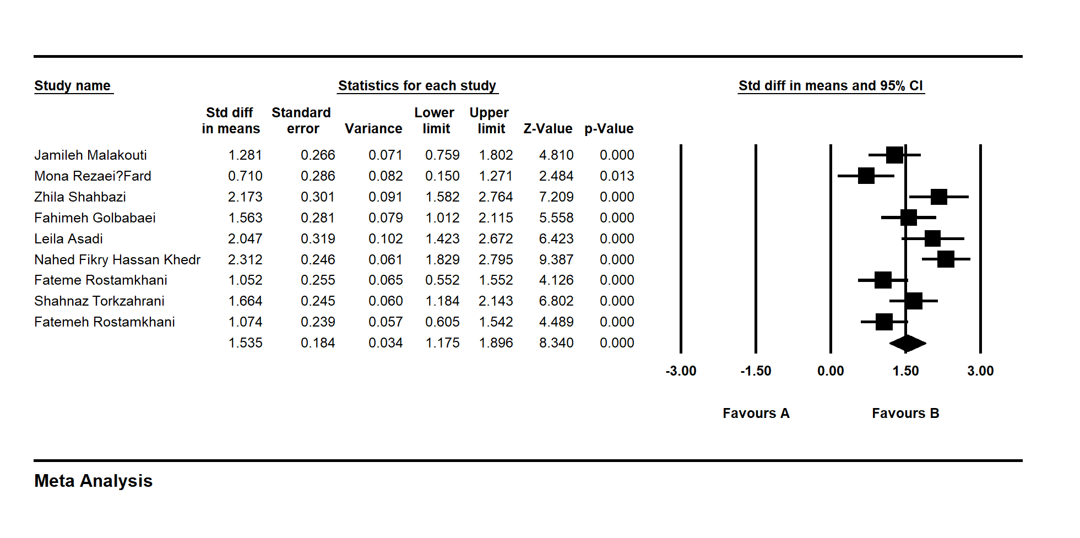
Figure 2. Effects of counselling on total score. The horizontal lines denote the 95% CI, ■ point estimate (size of the square corresponds to its weight); ♦, combined overall effect of treatment

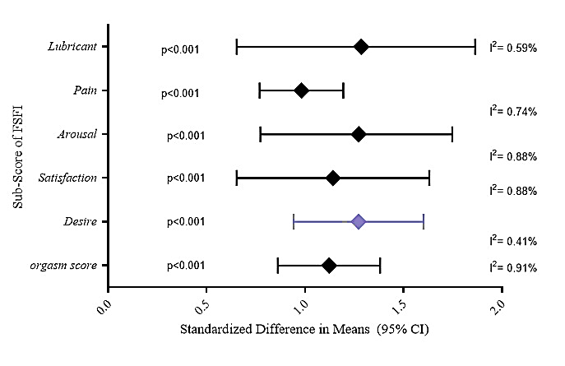
Figure 3. Effects of counselling on sub score of FSFI. (Standardized difference in means and 95% CI)
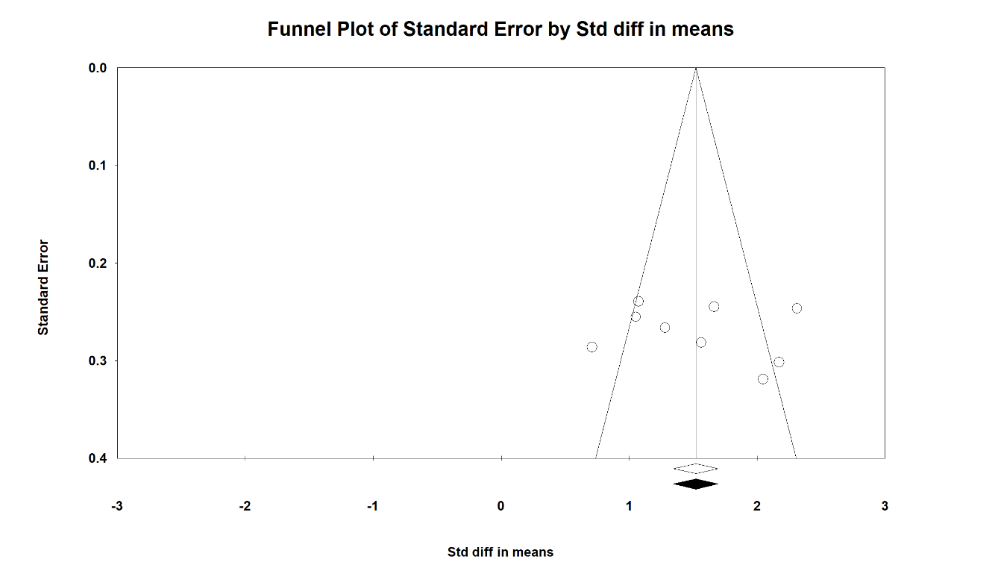
Figure 4. Funnel plot of Counselling Based on PLISSIT Model on Sexual Dysfunction

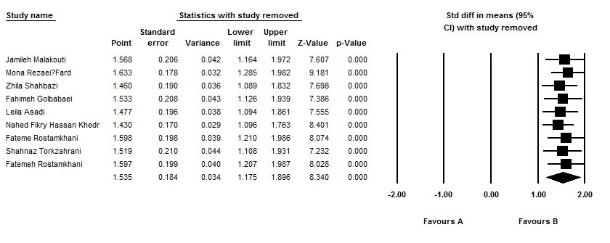

Figure 5. The results of the leave-one-out sensitivity analysis

Multiple Sclerosis Intimacy and Sexuality Questionnaire 19
Sexual Quality Of Life-Female
Expanded Disability Status Scale
Fatigue Severity Scale
Beck Depression Inventory
Female Sexual Function Index
Depression, Anxiety and Stress Scale - 21 Items
Brief Sexual Symptom Checklist for Women
MWSSQ Married Women’s Sexual Satisfaction Questionnaire
Revised Dyadic Adjustment Scale

